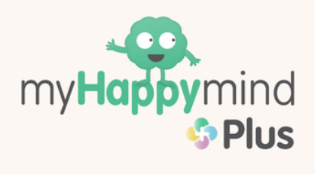



Autumn Term
Units – Safe Relationships & Economic Wellbeing.
Key Learning | Key Vocabulary
Meet Your Brain  - More about what their brain looks like and that it is fully grown by the age of 6.That our brain helps us to make good decisions and remember what we have learnt. That the Amygdala causes them to Fight, Flight or Freeze. Children will be asked to reflect and think of examples of how they use each of Team H-A-P. That when we learn something new, our brain remembers it and grows. They'll learn about Neuroplasticity and think of examples of how they can use it to help them. How they can use Happy Breathing to help Team H-A-P work as a team, but also how Happy Breathing can help with Neuroplasticity.  MyHappymind Places  - We are learning about different feelings that humans can experience. We are learning how to recognise and name different feelings. We are learning about ways of sharing feelings and a range of words to describe feelings. We are learning how feelings can affect people's bodies and how they behave. We are learning different things we can do to manage big feelings, to help calm ourselves down and/or change our mood when we don't feel good. We are learning about different feelings that humans can experience. We are learning about ways of sharing feelings and a range of words to describe feelings. We are learning different things you can do to manage big feelings, to help calm ourselves down and/or change our mood when we don't feel good. We are learning to recognise when we need help with feelings that it is important to ask for help with feelings; and how to ask for it.  Celebrate  - To think about what each strength means and some examples of the strengths in action. That when we use our Character Strengths, we can be our very best selves and that we all have our own unique set of strengths, and we are all different. What Neuroplasticity is and how we can grow our Character Strengths if we practise using them. About how to recognise the Character Strengths in themselves. How to think about which Character Strengths they would like to grow or use more of. | Brain, Cells, Team H-A-P, Hippocampus, Amygdala, Prefrontal Cortex, Happy Breathing, Neuroplasticity, Grow, ‘Fight, Flight, Freeze  Feelings, emotions, facial expressions, body, heart, strategies, Happy Place, Middle Place, Busy Place, Team H-A-P = Hippocampus, Amygdala, Prefrontal Cortex  Character Strengths, Love and Kindness, Bravery and Honesty, Exploring and Learning, Teamwork andFriendship, Love of Life and Our World, Unique, Special, Strength Spotting, Neuroplasticity, Grow

