


St Andrew’s C of E Primary School Maghull
EARLY YEARS FOUNDATION STAGE (EYFS)
POLICY
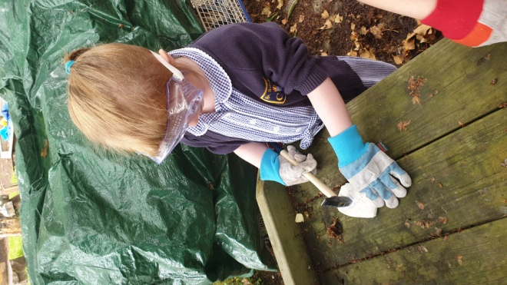
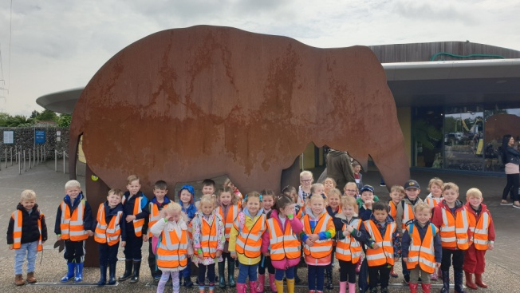

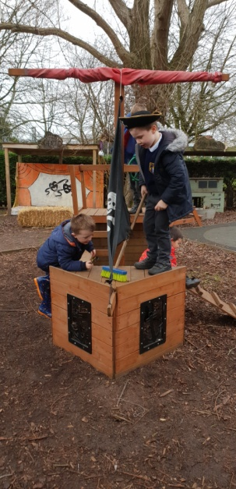
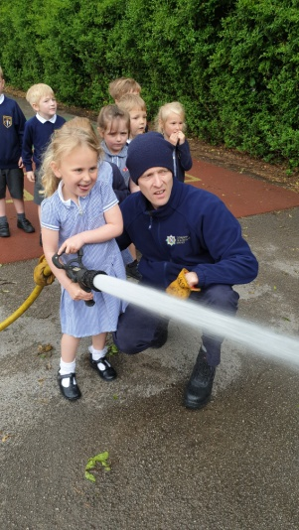
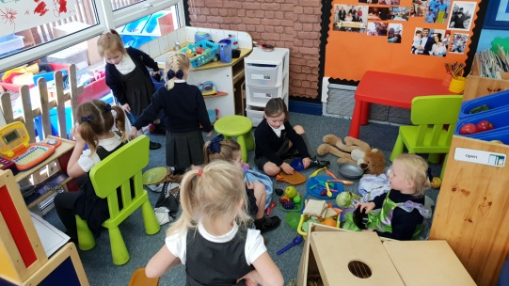

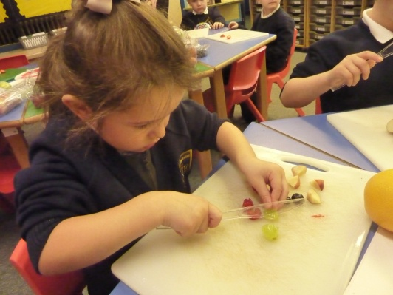

Introduction
‘Every child deserves the best possible start in life and support to fulfil their potential. A child’s experience in the early years has a major impact on their future life chances. A secure, safe and happy childhood is important in its own right and it provides the foundation for children to make the most of their abilities and talents as they grow up.’
Early Years Foundation Stage Profile - Department for Children, Schools and Families 2012

The Early Years Foundation Stage applies to children from birth to the end of the Reception year. At St Andrew’s Primary School children are admitted to Reception in the September following their fourth birthday.

At St Andrew’s Primary School we greatly value the importance that EYFS plays in laying secure foundations for future learning and development.
However, we also believe that early childhood is valid in itself as part of life. It is important to view the EYFS as preparation for life and not simply preparation for the next stage of education.
We are very proud of our Early Years Foundation Stage and achieving the Early Years Quality Mark in May 2015 and we continued the work that achieved that since.

Aims & Objectives
We aim to support all children to become independent and collaborative learners. We will provide a broad and balanced curriculum that will enable each child to develop personally, socially, emotionally, spiritually, physically, creatively and intellectually to their full potential.
At St Andrew’s Primary School, we will:
- Provide a happy, safe, stimulating and challenging programme of learning and development for the children to experience as they begin their journey through school.
- Provide a broad, balanced, relevant and creative curriculum that will set in place firm foundations for further learning and development in Key Stage 1 and beyond and enable choice and decision making, fostering independence and self-confidence.
- Use and value what each child can do, assessing their individual needs and helping each child to progress.
- Develop excellent relationships with parents and carers to build a strong partnership in supporting their children.
- Provide a caring and inclusive learning environment which is sensitive to the requirements of the individual child including those who have additional needs.
The early-years education we offer our children is based on the following principles:
- It builds on what our children already know and can do;
- It ensures that no child is excluded or disadvantaged;
- It offers a structure for learning that has a range of starting points, content that matches the needs of young children, and activities that provide opportunities for learning both indoors and outdoors;
- It provides a rich and stimulating environment;
- It acknowledges the importance of a full working partnership with parents and carers.

The Early Years Foundation Stage is based on four themes:
- A Unique Child
- Positive Relationships
- Enabling Environments
- Learning and Development

A Unique Child
At St Andrew’s Primary School we recognise that every child is a competent learner who can be resilient, capable, confident and self-assured. We recognise that children develop in individual ways and at varying rates. Children’s attitudes and dispositions to learning are influenced by feedback from others; we use praise and encouragement, as well as celebration and rewards, to encourage children to develop a positive attitude to learning.
Inclusion - We value the diversity of individuals within the school and believe that every child matters. All children at St Andrew’s Primary School are treated fairly regardless of race, gender, religion or abilities. All families are valued within our school.
We give our children every opportunity to achieve their personal best and planning is adapted to meet the needs of all groups and abilities. We do this by taking account of our children’s range of life experiences when we are planning for their learning.
At the Foundation Stage we set realistic and challenging expectations keyed to the needs of our children, so that most achieve the Early Learning Goals by the end of the stage. We do this through:
- Planning opportunities that build upon and extend children’s knowledge, experience and interests, and develop their self-esteem and confidence;
- Using a wide range of teaching strategies based on children’s learning needs;
- Providing a wide range of opportunities to motivate and support children and to help them learn effectively;
- Offering a safe and supportive learning environment in which the contribution of all children is valued;
- Employing resources which reflect diversity and are free from discrimination and stereotyping;
- Planning challenging activities to meet the needs of both boys and girls, of children with special educational needs, of children who are more able, of children with disabilities, of children from all social and cultural backgrounds, of children from different ethnic groups, and of those from diverse linguistic backgrounds;
- Monitoring children’s progress and taking action to provide support as necessary (such as referrals to speech therapy).
- Working closely with parents, carers and other outside agencies to ensure all children’s needs are met and we enable them to access the curriculum and make good progress.

Positive Relationships
At St Andrew’s Primary School we recognise that children learn to be strong, confident and independent from being in secure relationships. We aim to develop caring, respectful, professional relationships with the children and their families.
Parents as Partners - We recognise that parents/carers are children’s first and most enduring educators and we value being partners with them in their child’s education through:
- Talking to parents/carers before their child starts school at our open afternoons and induction meetings.
- Arranging, where possible, visits by the teacher to all children in their home setting or childcare provision prior to their starting school.
- Providing a handbook of information about commencing Reception at St Andrew’s Primary school.
- Outlining the school’s expectations in the Home-School agreement.
- Inviting parents/carers and children the opportunity to spend time in Reception Class every Tuesday morning for 40 minute stay and play sessions
- Providing an induction meeting for Reception parents/carers to meet with staff to discuss school routines, expectations and to answer any questions parents/carers may have.
- Issuing weekly ‘Reception Class’ newsletters to all families to keep them informed about what has been happening during the week and also what we have to look forward to in the coming weeks.
- Weekly home/school activities issued one per week with feedback boxes available for parents’ comments.
- Family after school clubs such as Family IT club and yoga.
- Open door policy which enables families to speak to the Reception staff before and after school each day.
- Regular twitter and website updates to share the children’s learning journey with their family.
- Holding a ‘Baseline Meeting’ early in the academic year to establish how a child is settling into the school environment.
- Inviting parents to attend informal meetings about areas of the curriculum, such as phonics or reading.
- Sharing regularly the children’s ‘Learning Journey’ with parents/carers and valuing the on-going contributions to this from parents/carers.
- Offering three parent/teacher consultation meetings per year (including the Baseline Meeting) at which their child’s progress is discussed.
- Sending a written report on their child’s attainment and progress at the end of their time in reception.
- Asking parents to sign a generic permission form for visits, food tasting and photographs etc.
- Parents are invited to a range of activities throughout the school year such as assemblies, workshops, Christmas productions and sports day etc.
- Offering opportunities for parents and carers to visit the school on a volunteer basis to assist with the children’s learning e.g. hearing readers.

Staff
Reception – 1 class teacher and 1 Key Worker (TA3).The EYFS Leader teaches the Reception class. All staff in the Foundation Stage aim to develop good relationships with all children, interacting positively with them and taking time to listen to them.

Enabling Environments
At St Andrew’s Primary School we recognise that the environment plays a key role in supporting and extending the children’s development, where the children feel confident, secure and challenged. The children have daily access to an indoor and outdoor environment that is set up in discrete areas of learning with planned continuous provision.
Play-based learning is paramount and children have opportunities to direct their own learning with planned opportunities provided by staff.
We plan a learning environment, both indoors and outdoors, that encourages a positive attitude to learning and reflects the individual’s interests, passions and abilities. We use materials and equipment that reflect both the community that the children come from and the wider world. We encourage the children to make their own selection of the activities on offer, as we believe that this encourages independent learning. We ensure that resources and spaces are safe to use and checked regularly.

Learning and Developing
The EYFS Curriculum – Our curriculum for the Foundation Stage reflects the areas of learning identified in the Early Learning Goals.
There are seven areas of learning and development that must shape educational provision in early years settings. All areas of learning and development are important and inter-connected. None of the areas of learning can be delivered in isolation from the others. Our children’s learning experiences enable them to develop competency and skill across a number of learning areas.
They require a balance of adult led and child initiated activities in order for most children to reach the levels required at the end of EYFS. Three areas are particularly crucial for igniting children’s curiosity and enthusiasm for learning, and for building their capacity to learn, form relationships and thrive.

The three Prime areas are:
- Personal, Social and Emotional Development
- Communication and Language
- Physical Development

Staff will also support children in four specific areas, through which the three prime areas are strengthened and applied.
Specific Areas:

- Literacy
- Mathematics
- Understanding the world
- Expressive arts and design

Children’s development levels are assessed and as the year progresses, the balance will shift towards a more equal focus on all areas of learning, as children grow in confidence and ability within the three prime areas.
However, if a child’s progress in any of the prime areas gives cause for concern, staff will discuss this with the child’s parents/carers and agree how to support the child.
Reception pupils also participate in a daily phonics sessions, following the guidance in the “Letters & Sounds” document and in line with school policy.

Characteristics of Effective Learning
We ensure that our environment and delivery of the curriculum incorporates the three characteristics of effective teaching and learning:
- Playing and exploring - children will have opportunities to investigate and experience things, and ‘have a go’. ‘Children’s play reflects their wide ranging and varied interests and preoccupations. In their play children learn at their highest level. Play with peers is important for children’s development.’ Through play, our children explore and develop learning experiences, which help them make sense of the world. They practise and build up ideas, learn how to control themselves and understand the need for rules. They have the opportunity to think creatively alongside other children as well as on their own. They communicate with others as they investigate and solve problems.
- Active learning - children will have time and space to concentrate and keep on trying if they encounter difficulties, and enjoy their achievements.
‘Children learn best through physical and mental challenges. Active learning involves other people, objects, ideas and events that engage and involve children for sustained periods.’ Active learning occurs when children are motivated and interested. Children need some independence and control over their learning. As children develop their confidence, they learn to make decisions. It provides children with a sense of satisfaction as they take ownership of their learning.
- Creating and thinking critically - we encourage and support children to have and develop their own ideas, make links between ideas, and develop strategies for doing things. Children should be given the opportunity to be creative through all areas of learning. Adults can support children’s thinking and help them make connections by showing interest, offering encouragement, clarifying ideas and asking open ended questions. Children can access resources and move around the classroom freely and purposefully to extend their learning.

Planning - The Early Learning Goals provide the basis for planning throughout the Foundation Stage. Teachers use the national schemes of work, where appropriate, to support their planning for individual children. The planning objectives within the Foundation Stage are from the Development Matters Statements from the Early Years Foundation Stage document. The planning is based upon themes with discrete phonics, maths and reading directed teaching. However, planning, which is based upon a different topic which is identified as vehicle of interest to deliver the children’s next steps in learning, also therefore responds to the needs, achievement and interest of the children. Our medium-term planning identifies the intended learning, with outcomes, for children working towards the Early Learning Goals, and also for those working towards National Curriculum levels.

Observations - Foundation Stage staff use observations as the basis for planning. Staff are skilled at observing children to identify their achievements, interests and next steps for learning. These observations then lead the direction of the planning. Relevant and significant observations are recorded in the children’s portfolio on Evidence Me.

Assessment - During the first term in Reception , the teacher assesses the ability of each child using a baseline observations. At St Andrew’s School we use information from home, nurseries and observations in the classroom, to determine each child’s starting points across the 17 areas of learning. We continue to assess the children throughout their time in Reception, enabling us to plan for each child ensuring that gaps are identified and all children make good progress.
We record each child’s level of development against the 17 early Learning goals as Emerging, Expected or Exceeding. We make regular assessments of children’s learning, and we use this information to ensure that future planning reflects identified needs.
Assessment in the Foundation Stage takes the form of both formal and informal observations, photographic evidence and through planned activities. Assessment is completed regularly and involves both the teacher and other adults, as appropriate. The collection of assessment data in the Foundation Stage Profile is a statutory requirement.
The teachers and key workers keep progress records and learning journeys through the use of Evidence Me. This contains a wide range of evidence that we share with parents on a regular basis. An online tracking system (Target Tracker) is completed at the end of each half term. This provides a summary for each child which feeds into the whole-school assessment and tracking process. We record each child’s level of development to be just working towards, comfortably working within or securely working within the Development Matters age-bands. The assessment information is shared with the Senior Management Team at Pupil Progress meetings at the start of each new half term. This ensures that any concerns are quickly recognised and action is taken.
At the end of the final term in Reception we send a summary of these assessments to the Local Authority for analysis. The child’s next teacher uses this information to make plans for the year ahead. We share this information with parents/carers in the end-of-year report.
Parents receive an annual written report that offers brief comments on each child’s progress in each area of learning. It highlights the child’s strengths and development needs, and gives details of the child’s general progress. We complete these in June, and send them to parents in early July each year.
The Learning Environment -The Foundation Stage classroom is organised to allow children to explore and learn securely and safely. There are specific areas where the children can be active, be quiet, creative etc.
Children have access to both inside and outside areas across the day; this has a positive effect on the children’s development. Being outdoors offers opportunities for doing things in different ways and in different scales than when indoors. The children can explore, use their senses and be physically active and exuberant. All areas of the curriculum can be explored outside.
Teaching & Learning Styles
The features of effective teaching and learning in our school are defined in our policy on teaching and learning. They apply to teaching and learning in the Foundation Stage just as much as they do to the teaching and learning in Key Stage 1 or 2.
The more general features of good practice in our school that relate to the Foundation Stage are:
- the partnership between teachers and parents, carers and other settings that helps our children to feel secure at school, and to develop a sense of well-being and achievement;
- the understanding that teachers have of how children develop and learn, and how this must be reflected in their teaching;
- the range of approaches that provide first-hand experiences, give clear explanations, make appropriate interventions, and extend and develop the children’s play, talk or other means of communication;
- the carefully planned curriculum that helps children achieve the Early Learning Goals by the end of the Foundation Stage;
- the provision for children to take part in activities that build on and extend their interests, and develop their intellectual, physical, social and emotional abilities;
- the encouragement for children to communicate and talk about their learning, and to develop independence and self-management;
- the support for learning, with appropriate and accessible space, facilities and equipment, both indoors and outdoors;
- the identification, through observations, of children’s progress and future learning needs, which are regularly shared with parents;
- the good relationships between our school and the other educational settings in which the children have been learning before joining our school;
- the clear aims of our work, and the regular monitoring of our work to evaluate and improve it;
- the regular identification of training needs for all adults working at the Foundation Stage.

Transition
Starting school can be a difficult time for young children; we therefore plan this time carefully to support children with the transition and to ensure it is as smooth as possible for each child and that they settle in to their new class quickly and happily.
Starting Reception – Parents of all children starting in the next academic year will be invited to a ‘New Intake Meeting’ in the Summer term to meet their child’s new teachers and other key staff and learn more about the Reception curriculum. This is an opportunity for staff to
- To highlight various school policies
- Explain about uniform, PE kit and school dinners/ free school meals
- Explain about holidays and absences
- Purchase uniform and book bag if requested
- Explain the arrangements for the gradual induction in to Reception

New class sessions - The children are given opportunities to come in to school to meet their new class teacher and other children in their class. They will spend a time in their new class. Parents can leave their child during this session.
This means that before they join their new class the Reception environment is already a familiar place to them.
Arrangements are also made for the children’s new class teacher to visit them in their current nursery setting where possible.
When children join the school in September, they will be phased in over 2-3 days, but will attend school full time from their first day. Although some schools offer mornings only during September, we welcome children to do full days to assist working parents.

Although it is not a legal requirement for children to be in school until their fifth birthday, foundation staff and the majority of parents/guardians agree that it is not in the best interests of an individual child starting school in Key Stage 1 (Year 1) - Throughout the Reception year, each child’s involvement in whole school life will have been built upon; many of the teaching and support staff will already be familiar people to them. They will have taken part in Key Stage and whole school assemblies as well as sharing playtimes with the Key Stage 1 children.
Children have the opportunity to meet their new class teacher and spend time in their new class during the summer term.
If a parent does not agree with their child starting school until they are five years old, a meeting will be arranged to discuss matters further.

Safeguarding & Welfare
‘Children learn best when they are healthy, safe and secure, when their individual needs are met, and when they have positive relationships with the adults caring for them.’
(Statutory Framework for EYFS 2014)
At St Andrew’s Primary School, we understand that we are legally required to comply with welfare requirements as stated in the Statutory Framework for Early Years Foundation Stage 2014.
- To provide a setting that is welcoming, safe and stimulating where children can grow in confidence;
- Promote good health;
- Manage behaviour effectively in a manner appropriate for the children’s stage of development and individual needs
- To ensure that all adults who look after the children, or who have unsupervised access to them, are suitable to do so;
- Ensure that the setting, furniture and equipment is safe and suitable for the purpose it was intended for;
- Maintain records, policies and procedures required for the safe efficient management of the setting and to meet the needs of the children.

Keeping Safe - It is important to us that all children in the school are ‘safe’. We aim to educate children on boundaries, rules and limits and to help them understand why they exist. We provide children with choices to help them develop this important life skill. We encourage children to take risks and highlight the importance of keeping themselves safe by teaching them how to recognise and avoid hazards. We aim to protect the physical and psychological well-being of all children.
Good Health - All children are provided with a healthy snack each day as well as being given the choice of milk. They have access to water at all times.
Intimate Care - “Intimate” care is any care which involves washing, touching or carrying out an invasive procedure that most children are able to carry out themselves. However, depending on a child’s age and stage of development, they may need some support, for example dressing, wiping their bottom after using the toilet and changing underwear following an accident.
In most cases, intimate care is to do with personal hygiene and it is good practise for the school to inform the school nurse of all children requiring intimate care.
Every child has the right to privacy, dignity and a professional approach from all staff when meeting their needs and it is important that staff work in partnership with parents to give the right support to an individual child.

School Trips
The Reception children will continue their learning through play and exploring while taking part in a variety of exciting trips. Recently these have included a walk to the local fruit shop, a trip to Windmill Farm where we re-enact the story of the first Christmas, a visit to the World Museum in Liverpool City Centre and an exciting day at Blue Planet aquarium. All trips have detailed risk assessments, copies of which can be provided on request.

Church/School Partnership.
We are very proud of our links with St Andrew’s church and have achieved the ‘Church School Partnership 2 Award.’
Reception children take part in weekly whole school collective worship which takes place either in the school hall or in church and is delivered by a representative from Kings Church in Thornton. We also have worships delivered by the clergy.
The children also have weekly RE lessons which help them to focus on all of the Christian Values.
At St Andrew’s school, we welcome children from all faiths and none. We embrace other cultures learning about different festivities throughout Reception and in years 1-6.
Recently we have started a ‘buddies’ group for children from Reception to get to know some of the members of the church congregation.

Monitoring and Review
It is the responsibility of those working in Reception to follow the principles stated in this policy. The Head teacher and EYFS co-ordinator will carry out monitoring in EYFS as part of the whole school monitoring schedule. The Curriculum Committee of The Governing Body will also be part of this process.

Phil Taylor reviewed March 2021
Next review due – March 2022

