Year 2 – Summer 1
Vehicle Text – The King Who Banned the Dark
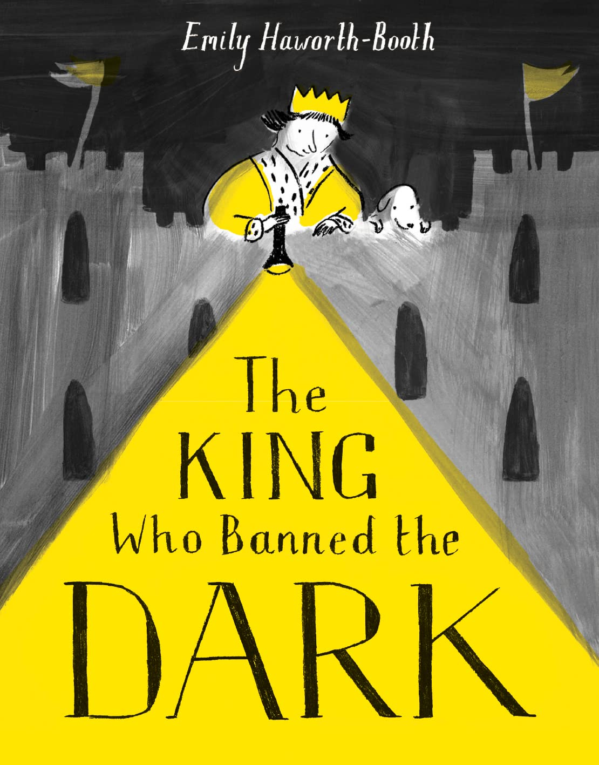

Word Focus:
Formation of nouns using suffixes e.g. –ness, –er
and by compounding
Formation of adjectives using suffixes e.g. –ful, –less
Use of the suffix –ly to turn adjectives into adverbs
Sentence Focus:
Expanded noun phrases for description and specification
Subordination (using when, if, that, because)
Co-ordination (or, and, but) How the grammatical patterns in a sentence indicates its function as a question, exclamation and statement.
Text Focus:
Correct choice and consistent use of past and present tense throughout writing including progressive forms of verbs
Punctuation Focus:
Use of capital letters, full stops, question marks and exclamation marks to demarcate sentences
Apostrophes to mark singular possession in nouns
Commas to separate items in a list
Written Outcomes:
Narrative – Banning Narrative
Purpose – To narrate
Information – Letter
Purpose – To inform

